Brochure
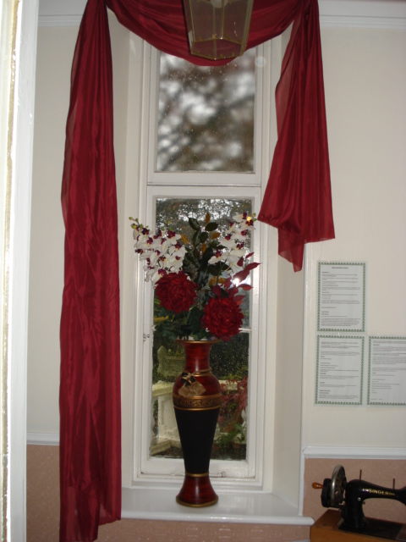

Mount Pleasant Care Home
26 Mount Pleasant Road
Newton Abbot
TQ12 1AS
Devon
Registered Company name: Davack Ltd
Care Home Manager: Mrs Sian Littlechild H.N.D, R.M.A
Care Home Responsible person: Mrs Tracy McLellan

Tel No: 01626 201474 E-mail:davackltd@aol.co.uk www.mountpleasantcarehome.com

CONTENTS
Page no.
- Contents
- Introduction
- Homes fee structure
- Services that mount pleasant provide
- What the papers had to say about us
8. Staffing and information on other services and advice available
9. Kitchen facilities and care plans
10. Religious services and arrangements for pets
11. Arrangements for maintaining contact with relatives

WELCOME TO MOUNT PLEASANT CARE HOME

Mount Pleasant is a homely, spacious, privately owned care facility in Newton Abbot, which has successfully gained the nationally recognized “Investor in People” award for the past six years.
It is a large semi-detached Victorian property with gardens to the front and a secure, secluded town garden to the rear with large decked area , where clients and their visitors can wander or relax in a tranquil setting.
The home is situated on a hill with spectacular views overlooking the market town of Newton Abbot and out towards Dartmoor and the Teign valley. We are approx ½ mile from the town centre where there are local shops, post offices, Doctors surgery’s churches, pharmacies. The hospital is only a 5 minute walk away.
There is visitor’s parking at the front of the house. We are a 10 minute walk from Newton Abbot Train station where regular bus and train services are available to all local areas including Torquay and Exeter.
We have a local taxi company who deal specifically with our client group and their families they have been vetted and they provide an excellent personal service
Accommodation is provided on 2 floors with access via a stair lift. The ground floor consists of 4 single bedrooms, one of which has an en suite, a newly refurbished dining room, large lounge area, kitchen, laundry room, and office, 1 bathroom with hydro bath and 2 toilets with raised toilet seats. The upper floor consists of 6 single rooms, three of which have en-suite, 2 double rooms with dividing curtains, 1 shower room with seat, 1 bathroom with hoisted bath, 2 toilets with raised toilet seats. All rooms are centrally heated and all taps are thermostatically controlled in accordance with Health and Safety regulations. The home is fully compliant with Health and Safety regulations, with up to date risk assessments.
Homes fee structure.
Our weekly charge is £450 irrespective of funding (private or socially funded), which includes daily living, all meals (including special dietary needs), in house laundering, individual room, appropriate staff to care for usual daily needs.
We also offer a daycare facility, our daily charge is £41.50, this is to included meals, transport to and from Mount Pleasant, bathing/showering facilities and a massage therapy.
Other services we provide at Mount Pleasant are:
General Practitioner – clients have a choice of GP in the area, if for any reason they wish to change GP, we do have an excellent clinic held by one local GP once a month in house.
District nurses – are regular visitors into the home and will always be available for advice or to administer treatment for clients who need it.
Chiropodist – visits every six weeks who sees the clients on an individual basis in a private room.
Optician – visits annually or on request, and clients will be seen in a private room.
Dentist – visits four monthly and clients will be seen in a private room.
Hairdresser – visits weekly, providing perms, haircuts, wash and sets which are all provided at a reasonable cost.
Reflexology and Aroma therapist – visits twice weekly to provide alternative therapies to all who choose. The service is carried out in a private room and provided at a reasonable cost.
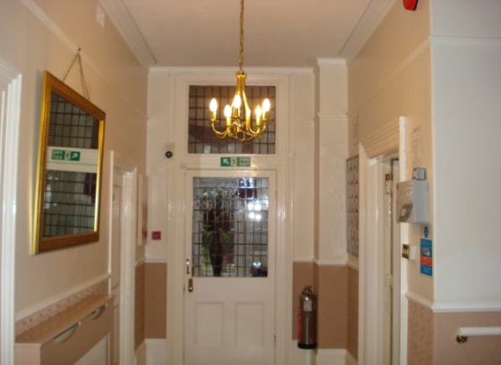

WHAT THE PAPERS HAD TO SAY ABOUT US
“People prize for care home “- Mid-Devon Advertiser
A prestigious prize has been won by a top Newton Abbot Care home. The Mount Pleasant care home won the investor in People award for its constant commitment to training and developing its staff. Sian Littlechild, who owns the home with her business partner Tracy McLellan, said, “Investor in People recognition is very important to us. It is one way of showing the staff just how important they are to us and to the home itself” “We have a tremendous team in place here, and we are all delighted that the teamwork has been noticed.” The home’s commitment has earned it glowing praise from client’s relatives and GP helping it to maintain 100% occupancy in the face of stiff opposition from rival homes across Devon. It specialises in 24 hour care for sufferers of Alzheimer’s and other associated Dementias. “
“Home makes sound investment “. - Herald Express
“A Newton Abbot residential home that has built an outstanding reputation for quality care is celebrating after being recognised as an Investor in People by PROSPER Business link services.
Mount Pleasant Care home has demonstrated a clear commitment to training and development providing its enthusiastic staff with the skills needed to care for some of society’s most vulnerable citizens. Mount Pleasant prides itself on providing a high level of care. It is perhaps the only EMI home in the area to provide an activities co-coordinator and in house access to reflexology, aromatherapy and massage treatment. Their next target is to provide a separate sensory and snooze unit.
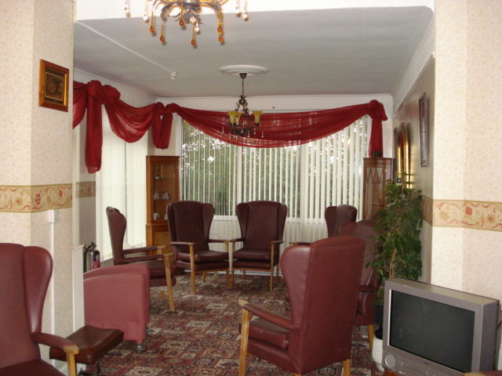
The home which is operated by Davack Ltd and employs 14 staff providing around the clock care for 14 clients. Mount Pleasant also operates an active NVQ programme, providing staff with numerous opportunities to gain levels 2 – 4 qualifications in care. Other training opportunities are linked to external qualifications such as an Alzheimer’s society certificate, health and safety, food hygiene, first aid and manual handling. Investor in People recognition, which was achieved in just three months, marks a double celebration for the home. Within days of reaching the Investor in People, Care Manager Sian Littlechild achieved her Higher National Diploma in Care Management; Sian now wants to further her studies to achieve a degree in Care Management.
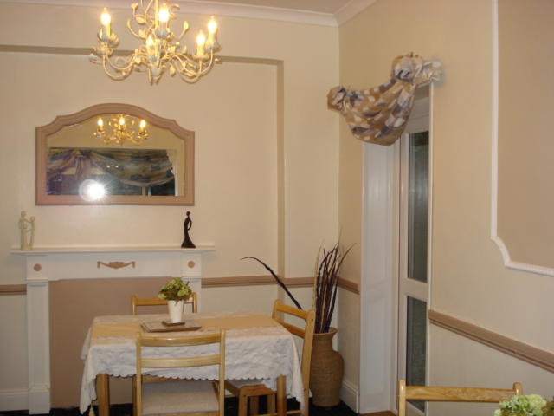
In recommending Mount Pleasant Care Home for recognition as an Investor in People assessor Alison Cox said “The on-going development of people is seen as fundamental to running the home. This is reinforced by a high level of commitment and loyalty shown by all staff to the home and the clients within it. There is an enthusiasm for teamwork throughout the home

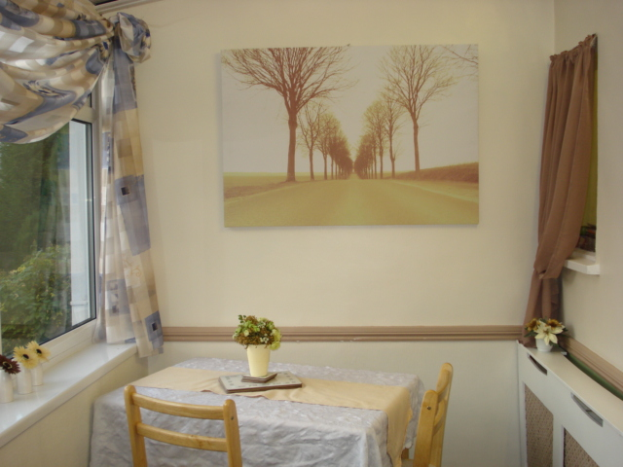

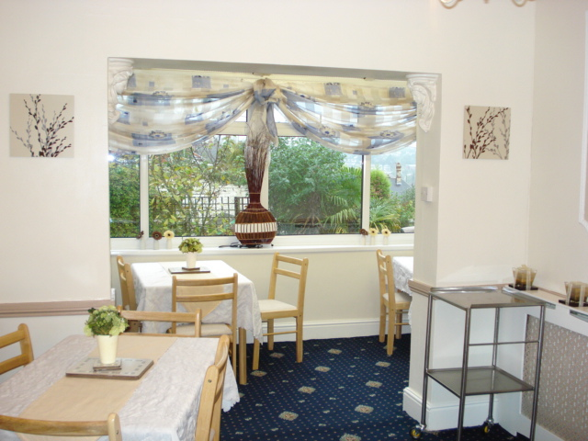

Staffing
All the staff are highly qualified care staff who are accredited by the Alzheimer’s society and all have an NVQ 2 or above. Staffs are always on duty to plan and supervise clients care, ensuring the highest standards at all times. .
Personal use of the telephone
Our home has no extra phone lines, clients may receive and make private calls on the home digital mobile handset in the privacy of their own rooms.
Administration support
This is available to clients who may require a letter to be typed, or any help with the administration of their affairs.
Benefits advice
This can be provided via the manager, Sian Littlechild, information can be obtained about pensions and social security benefits.
Shopping
Where appropriate we encourage clients to go shopping under supervision, with relatives and staff. All monies spent will be billed to relatives or solicitors with receipts if other arrangements have not been previously agreed.
Laundry
Is undertaken within the home which is included within care fees. The laundry equipment achieves the care standards and the 1998 water regulations. The home expects all personal clothing to be labeled and tumble dryable and cannot be held responsible for any loss of items or damage of such items. There are no facilities for clients to do their own laundry and washing of personal items in rooms is not encouraged due to reasons of Health and Safety.

Kitchen facilities
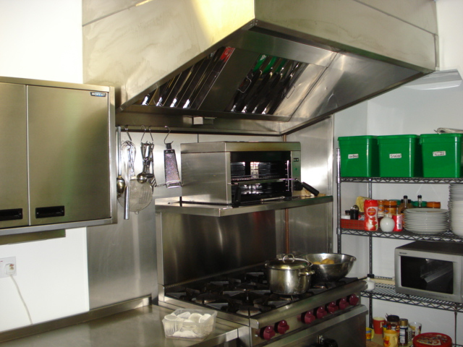
A brand new kitchen has been fitted with every piece of equipment needed to facilitate the client’s needs. All appliances are compliant with the Environmental health department. The kitchen is managed by the cook. Clients and relatives are able to access the kitchen facilities but must ensure that a member of staff is aware of them entering the kitchen, this is due to Health and Safety at Work Act 1998. Clients and relatives can avail themselves of drinks and snacks at most times again requesting the assistance of the staff.
Arrangements for viewing the personal care plan
The home operates a full planning and review system. On admission each client is assessed and a plan of care formulated. This plan will cover all areas of a client’s life and will not focus purely on problems and physical matters but aims to enhance the client’s quality of life. A comprehensive profile of the past history and present and future objectives is produced for each client including interest and activities.
Arrangements for clients attending religious services
Our home takes all reasonable steps to ensure that each client wishes are known and understood about their religious preference, and they can practice within their chosen religion. Where requested, we will observe and ensure confidentiality in respect of religious beliefs or alternatively we will take such steps as may be necessary to enable clients to attend religious services or access religious leaders, ministers or priests in private
Arrangements for social activities, hobbies and leisure interests
Our home is able to provide a variety of ways that clients can engage in the enjoyment of social activities, hobbies and leisure interests. Client’s individual wishes regarding involvement in activities will be respected. We endeavour to strike a balance between gentle encouragement and respecting wishes not to participate. The home employs an activity organiser. The range of activities available is set out on the homes information notice board which is located in the porch.
Arrangements for pets
The home has no set policy on pets; each case is given individual consideration.
Arrangements for client’s consultation about the home
The home is committed to ensuring that the clients or their representatives are fully consulted about matters which are significant to the running of the home or about matters which might affect their well being or quality of life wherever possible. The management and staff are always available to listen to the views of the clients.
Arrangements for maintaining contact with relatives, friends, and representatives
The home actively encourages clients to maintain all forms of social contact that they enjoyed before entering into the home. We will assist clients to maintain contact if required when and wherever possible.
This is the client’s home and hence, subject to the clients wishes, visitors are, within reason, generally welcome at any time.
If any further information is required please do not hesitate to contact Sian Littlechild on the above telephone number, e-mail address or postal address.
View our latest registration report on the CQC website: www.cqc.org.uk

